**FACULTY OF MECHANICAL ENGINEERING**

**“In the name of Allah, The Most Beneficent, The Most Merciful”**

Date Delivered:

|  |  |
| --- | --- |
| **Lab 1 : CAM design** | |
|  | BMM4723 Mechanism Design  ­  **Lab Instructors**  **Dr. Agung Sudrajad**  **Mr. Muhamad Zuhairi bin Sulaiman**  **Dr. Maisara Mohyeldin Gasim Mohamed**  **Lab Location**  Static dynamics Laboratory |
|  | **Lab Objectives**  By the end of laboratory, students should be able to:   * XXXXXXXXXXX |
| **20** | |  |  |  |  | | --- | --- | --- | --- | | **Group Members** | **Student ID** | **Contribution of work**  **(100%)** | **Section** | |  |  |  |  | |  |  |  |  | |  |  |  |  | |  |  |  |  | |  |  |  |  | |
| **100** |

Date of Experiment:

**An Evaluation of Profiles for Disk Cams with In-line Roller Followers in Horizontal Position**

**Name1, Name2, ……., Name15**

Faculty of Mechanical Engineering, Universiti Malaysia Pahang, Pekan, 26600 Gambang, Kuantan, Pahang, Malaysia.

**Abstract: ……………………….**

**Keywords**: …………………………….

**INTRODUCTION**

………………………………

**EXPERIMENTS**

……………………………..

**Cam Mechanism Analysis System**

In analyzing cam motion mechanism, the machine that had been used is cam mechanism analysis system, as shown in Fig. x. This system is used Dewesoft software to run and gathering the experimental data.

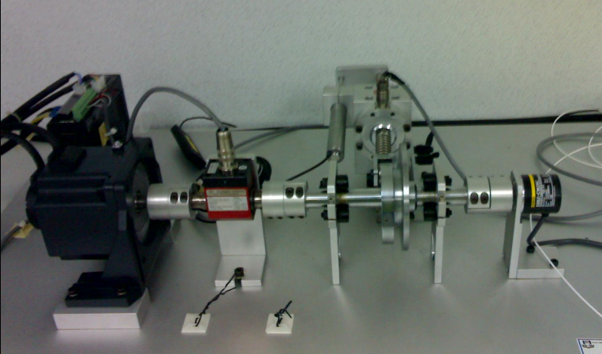

Cam

Follower

LVDT

Figure x. Cam mechanism analysis system

From this experiment, the parameters that gathered were displacement (*s*), velocity (*v*) and acceleration (*a*) of the follower. From this data, the performance of the cam and follower system can be analyzed and had been compared with the theoretical analysis.

**Data collection method**

From the …….. shape of cam that had be used, the performance of this type of the cam using kinematics parameter can be differentiate from the experiment in the cam mechanism analysis system using different speed of cam. In this experiment, the speeds of cam that used were 100 rpm, 200 rpm, 300 rpm, 400 rpm, 500 rpm and 600 rpm.

**RESULTS & DISCUSSION**

From the experiment, the output is in form of graphs (displacement, torque, force, vibration and speed) versus time (Fig. xx), and the raw data is about the 60000 data for every single experiment. Figure below show mode output data while doing experiment with input 100 rpm.

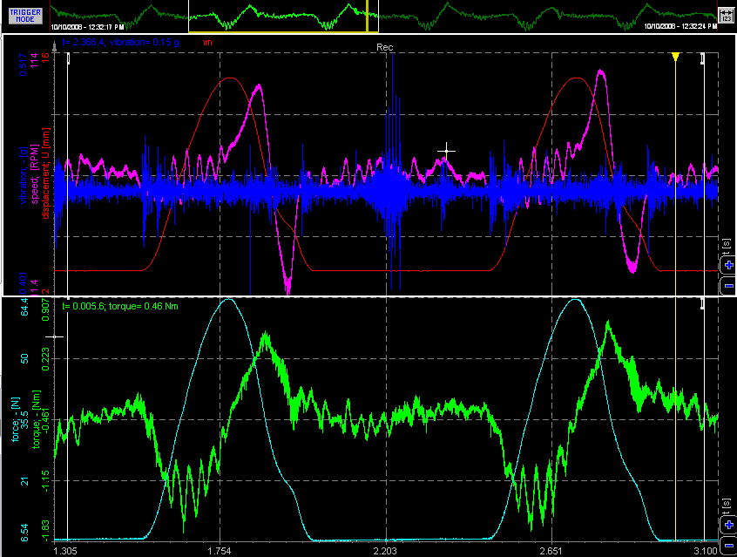

Figure xx. Graphs of output data of 100 rpm for one complete cycle

The data gathered can be interpreted due to kinematics analysis, which meaning that, the data can be reconstructed in form of displacement, velocity and acceleration analysis. For that, the data for one cycle of cam rotation (*β* =360o) was determined.

Fig. xxx shows the displacement diagram, velocity diagram, and acceleration diagram, after reconstructed of the output data for one complete cycle of the experiment using speed of 100 rpm.

FIGURE

Figure xxx. Follower displacement diagram (a), velocity diagram (b) and acceleration diagram (c) versus cam angle at 100 rpm

For other input value (200 rpm, 300 rpm, 400 rpm, 500 rpm, 600 rpm), its show same pattern of graph. In the follower displacement graphs, they have same value and same pattern graph of the diagram. The differences among the input value are the maximum value of velocity and acceleration that has change constantly with the change of speed of the cam (see Fig. xxxx and Fig. xxxxx). For this shape of cam, the maximum value of displacement, velocity and acceleration are summarized in the Table 1 according to the input value.

FIGURE

Figure xxxx. Follower velocity diagram in 6 different speeds

FIGURE

Figure xxxxx. Follower acceleration diagram in 6 different speeds.

Fig. xxxx shows …… *discussion*

In contrast with the follower acceleration diagram (Fig. xxxxx), ………*discussion*

Table 1. Maximum values for experimental method

|  |  |  |  |
| --- | --- | --- | --- |
| Speed (rpm) | Displacement (mm) | Velocity (mm/s) | Acceleration (mm/s2) |
| 100 |  |  |  |
| 200 |  |  |  |
| 300 |  |  |  |
| 400 |  |  |  |
| 500 |  |  |  |
| 600 |  |  |  |

**Cam profile analysis**

From Fig. xxxxxx, it shows a little difference between graphical method and experimental method. It may occur when reconstruction of cam profile between actual cam compare to experimental data. But from analysis, it shows the small different between actual cam and experimental data of construction cam.



Figure xxxxxx. Comparison of cam profile between graphical and experimental methods

From comparison between graphical and experimental methods, …………. *discussion*

Table 2. Error occur during the experiment compare to graphical methods

|  |  |  |  |
| --- | --- | --- | --- |
| Speed (rpm) | Displacement (%) | Velocity (%) | Acceleration (%) |
| 100 |  |  |  |
| 200 |  |  |  |
| 300 |  |  |  |
| 400 |  |  |  |
| 500 |  |  |  |
| 600 |  |  |  |

The detail of the percentage errors between graphical and experimental methods had been summarized………….. *discussion*

**CONCLUSION**

……………………………….

**ACKNOWLEDGMENT**

The authors would like to express their thanks to……………

**REFERENCES**

1. Zhang Y., Finger S. and Behrens S., (2006), *Rapid Design through Virtual and Physical Prototyping*, Carnegie Mellon University.
2. Erdman A.G. and Sandor G.N., (1964), *Mechanism Design: Analysis and Synthesis Vol. 1*, Prentice Hall, New Jersey.
3. Chen F. Y., (1982), *Mechanics and Design of Cam Mechanisms*, Pergamon Press, New York.
4. Myszka D.H., (2005), *Machines & Mechanisms*, Pearson Prentice Hall, Third Edition, New Jersey.
5. Jensen P. W., (1987), *Cam Design and Manufacture 2nd ed,* Marcel Dekker Inc.
6. Lee R. S. and She C. H., (1998). Tool path Generation and Error Control Method for Multi Axis NC machining of Spatial Cam. *International Journal Machine Tools Manufacturing*. **38 (4)** 277-290.
7. Rothbart, H.A., (2005), *Cam Design Handbook*. McGraw-Hill Handbooks, New York.
8. xxxx
9. xxxx
10. xxxx